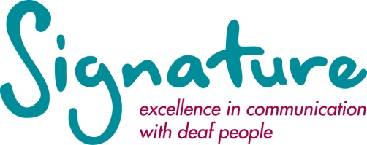

JOB DESCRIPTION

Administration Support Officer

Responsible to: | Business Service Manager
Job summary: | The prime role of the post holder is to provide administration support across the organisation.

Key Tasks

- Provide administrative support across the business services team and the wider organisation if needed.

- Typing of letters, reports and responding to routine correspondence, within specific time frames.

- Open and distribute incoming post and frank outgoing post.

- Assist with the adminitrastion within the Customer Support Team including, data input of assessment information, assessment results, exam board confirmations, certificates, pre-assessment documentation and dealing with basic phone and email enquiries.

- Assist with the administration in the area of NRCPD registration. This includes dealing with aspects of general correspondence, both written and by phone to ensure smooth delivery of service, and processing of registration applications.

- Assist with the administration of Signature’s training programme, including booking venues/refreshments, issuing course information to participants/trainers, copying and distribution of course materials.

- Carry out any other duties which may reasonably be expected of the post holder.

Relationships

Internal: Business Service Manager and all staff.
External: Signature Customers and centres.

Equipment / Software Used

Microsoft Office Suite
Sage HR software
Telephone/Textphone/Short Message Service (SMS)
Affiliate

Updated 11/14

PERSON SPECIFICATION

Administration Support Officer

Requirements | Essential | Desirable
Education | Educated to GCSE level or equivalent including English Language and Maths (or able to demonstrate equivalent standard) | Educated to ‘A’ level or equivalent
Qualifications | Level 2 NVQ in Business administration (or able to demonstrate equivalent standard) | Level 2 NVQ in Customer Service  Level 1 Certificate in BSL
Experience | Demonstrate at least one year’s experience working in an office environment where delivering a high degree of accuracy have been necessary.
Knowledge | Computer literate including Microsoft Office suite. | Knowledge of databases.
Skills & abilities | Strong customer service orientation.  Ability to follow a process from start through to fruition.  Excellent communication skills.  Organisational skills with a systematic and methodical approach to work.  Self motivated.  Ability to manage own workload in a high volume environment with accuracy and attention to detail.  Ability to remain calm under pressure.

Location and working hours | The post is based in the Durham Headquarters of Signature which is located in Mersey House, Mandale Business Park, Belmont, Durham, DH1 1TH. This is a non-smoking building.  Working hours – full time 37 hours per week.
Salary | Full time, circa £15,500 to £16,500 gross per annum (dependent upon experience).
Holidays | Full time – 25 working days per year plus recognised bank or public holidays currently 8 in all. Of the 25 days holiday, you must keep up to 3 days each year to bridge the gap between Christmas and the New Year, when the office closes.
Requirements | Post is subject to a 6 month probationary period and receipt of references satisfactory to us.  Employees are expected to complete the following Signature courses within 2 years of commencing employment:  - Level 1 Certificate in Developing Communication and Awareness with Deaf and Deafblind People.  - Level 1 Certificate in British Sign Language.
Pension | Signature operates a voluntary pension scheme through the Pensions Trust.

Updated 11/14

