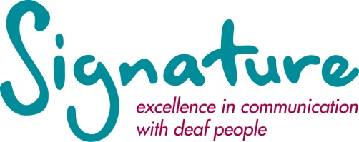

PRESENTER FOR FILMING

Overview
Signature requires an engaging, charismatic personality to work with us on small project.

The successful applicant will be filmed while presenting, Signature training course content and supporting material content, in British Sign Language. The filmed content will then be uploaded to our online training platform and viewed by customers who purchase the training programme.
The filming will take place at a studio and be overseen by a Signature consultant. The applicant will be expected to communicate with the Signature team and practice the content, prior to the filming date. This can be done from a distance.

Pay
The rate of pay is £120 per day (10am – 4pm) and is on a self-employed basis. The number of preparation and presenting days are yet to be confirmed but it will be at least 4 days. Plus agreed travel expenses.

Essential criteria for the role

- Level 6 qualification in British Sign Language (or equivalent).

- Working to strict time limits.

- Excellent presentation skills.

- Excellent organisational and time management skills.

- Excellent preparation skills and attention to detail.

- Excellent communication skills.

- Good level of understanding the English language - written

- Strong initiative, drive and enthusiasm.

- Flexible and adaptable.

- Creative, dynamic and innovative.

- Ability to work under pressure and meet deadlines.

Desirable criteria for the role

- Experience of Translating English to British Sign Language.

- Working in a teaching environment.

- Knowledge of Signature Level 3 and Level 4 British Sign Language qualifications.

- Experience of presenting to camera.

